DUST EXTRACTION D25300D - WIRE POSITIONING

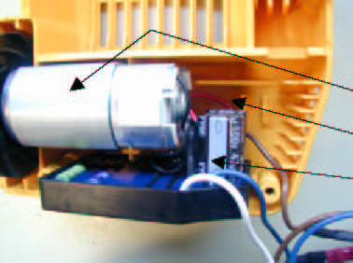
MOTOR AND ELECTRONIC

- OPEN SIDE OF MOTOR KEEPER RING DOWNWARDS

- RED WIRE OF MOTOR DOWNWARDS

- BLACK WIRE OF MOTOR UPWARDS

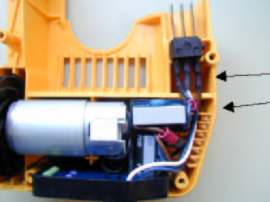
INSERT PIECE (3er-TERMINAL)

- WIRE ON INSERT PIECE LIKE THE MARKINGS

- ALL WIRES IN WIRE GUIDE

