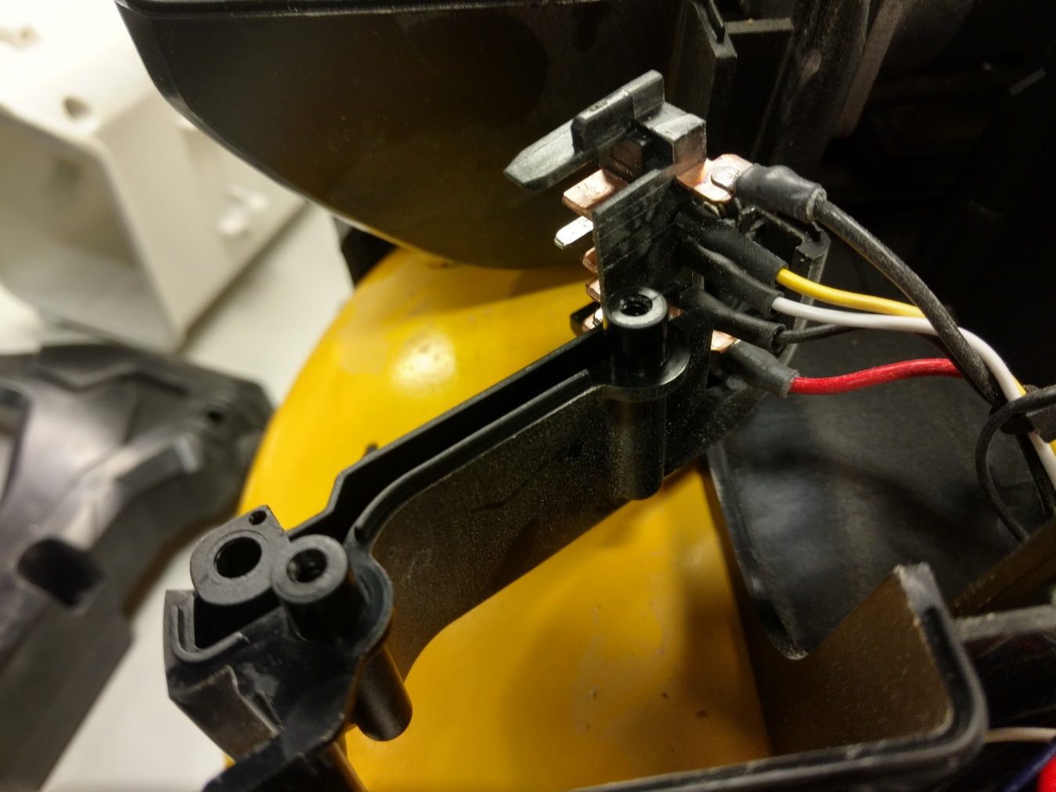

Insert terminal block into tool foot.

**PLACE CONNECTOR INTO POSITION**

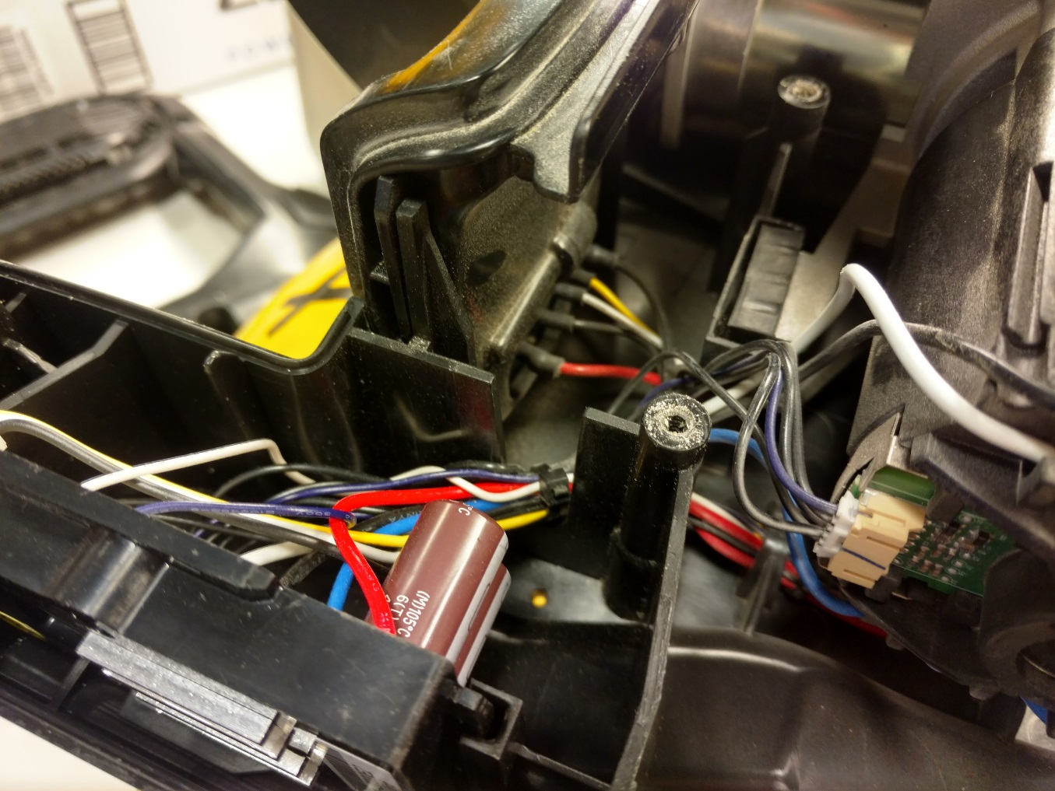

Close tool foot and insert into housing. Wires oriented as shown.

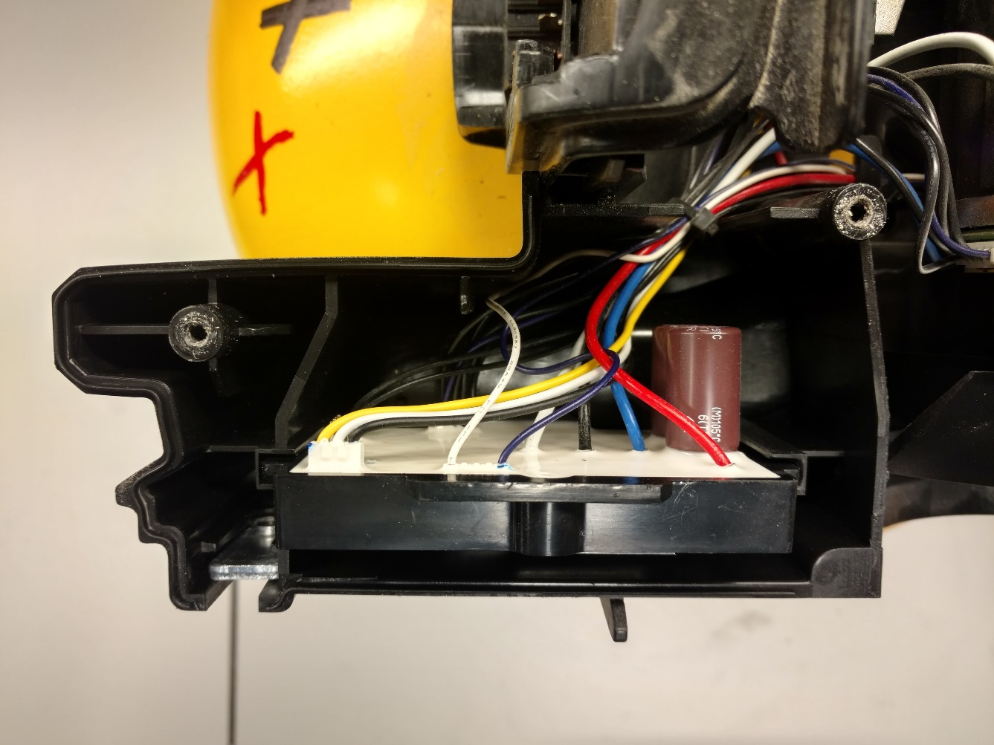

Insert PCBA module into location as shown.

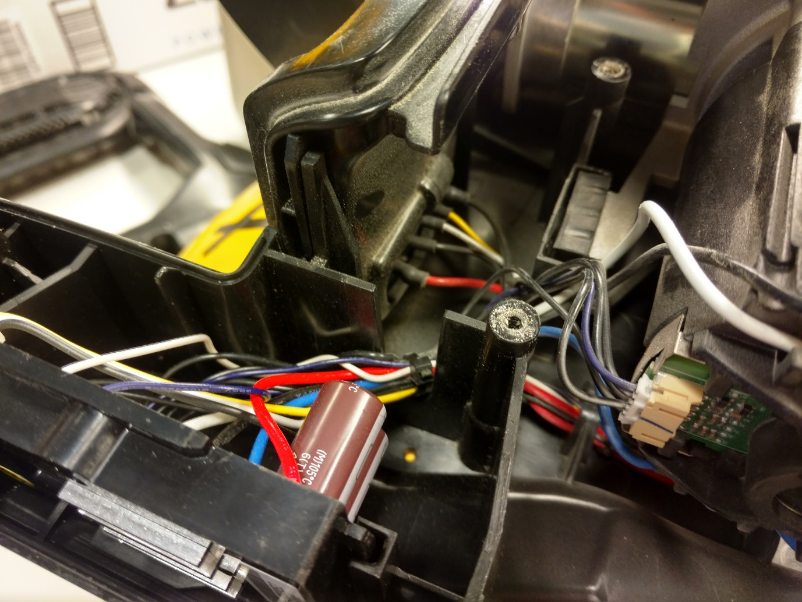

Route wire bundle through location shown.

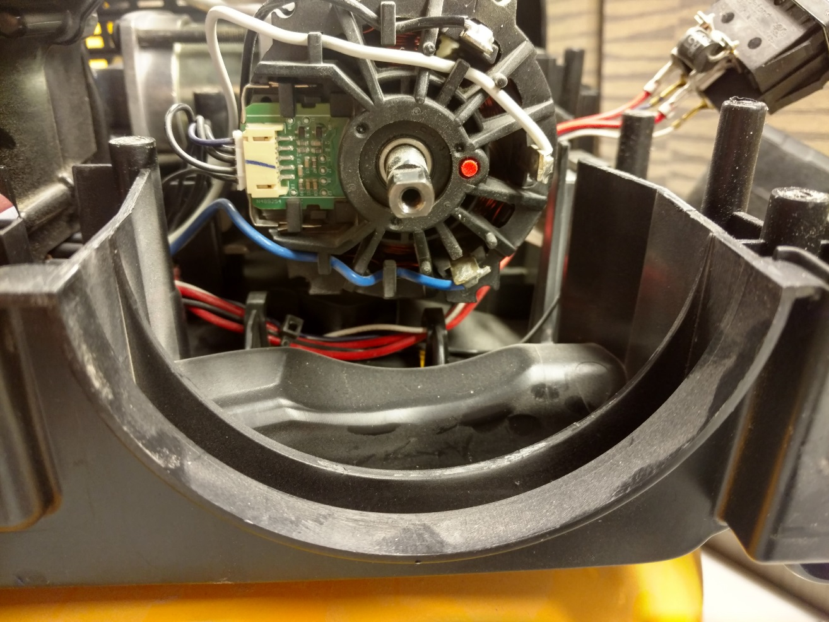

Attach motor wires and hall sensor harness as shown.

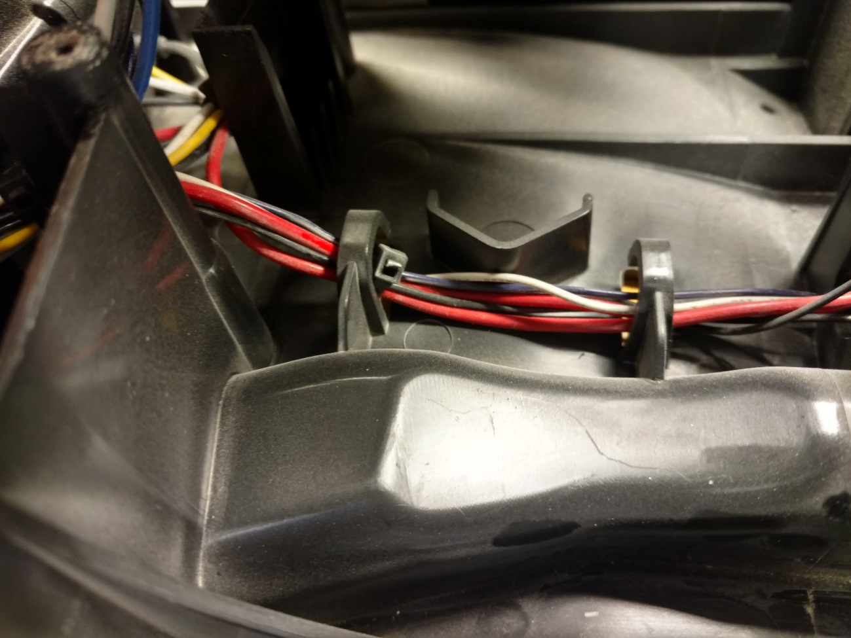

Route wire bundle through wire traps underneath motor.

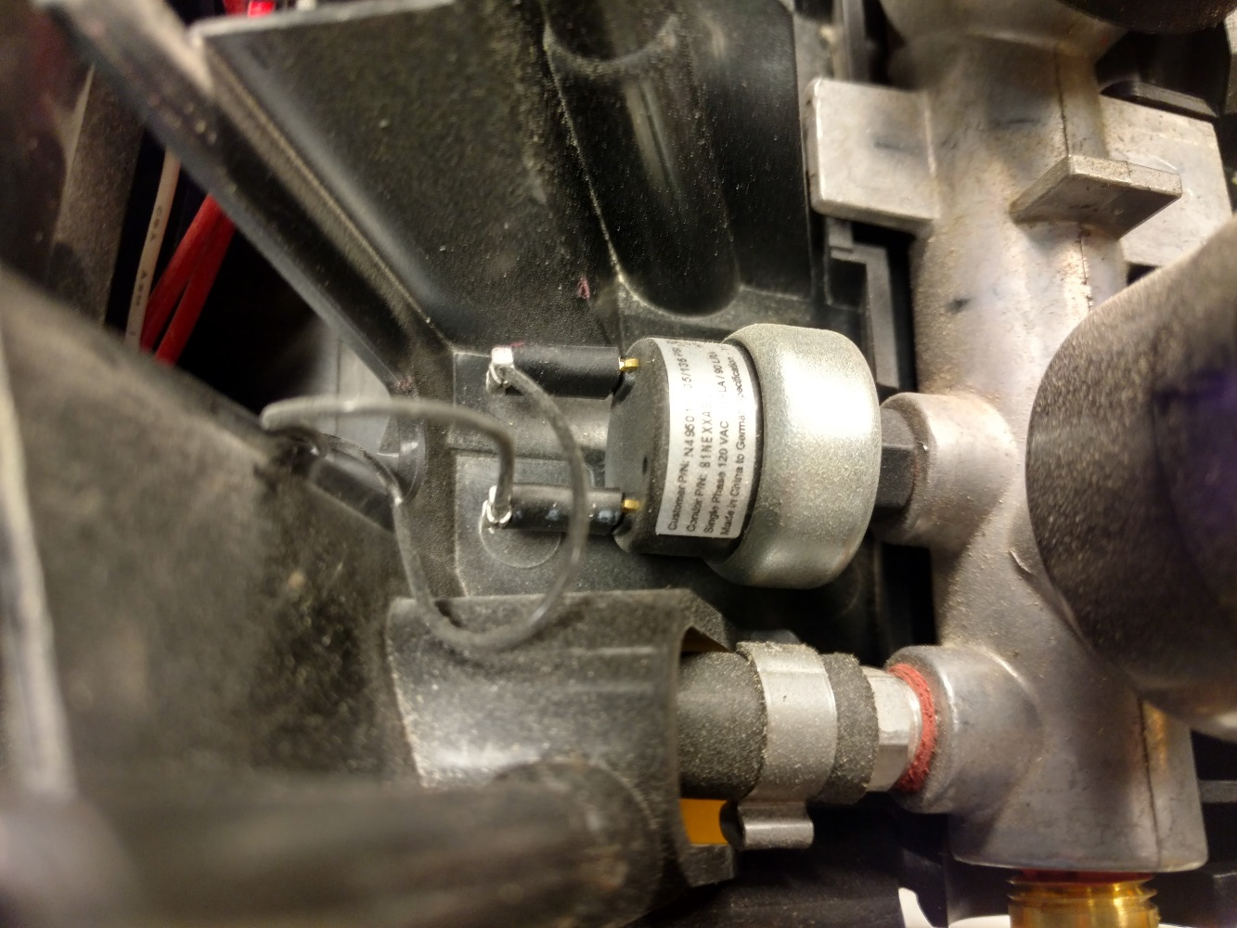

Attach wires to pressure switch

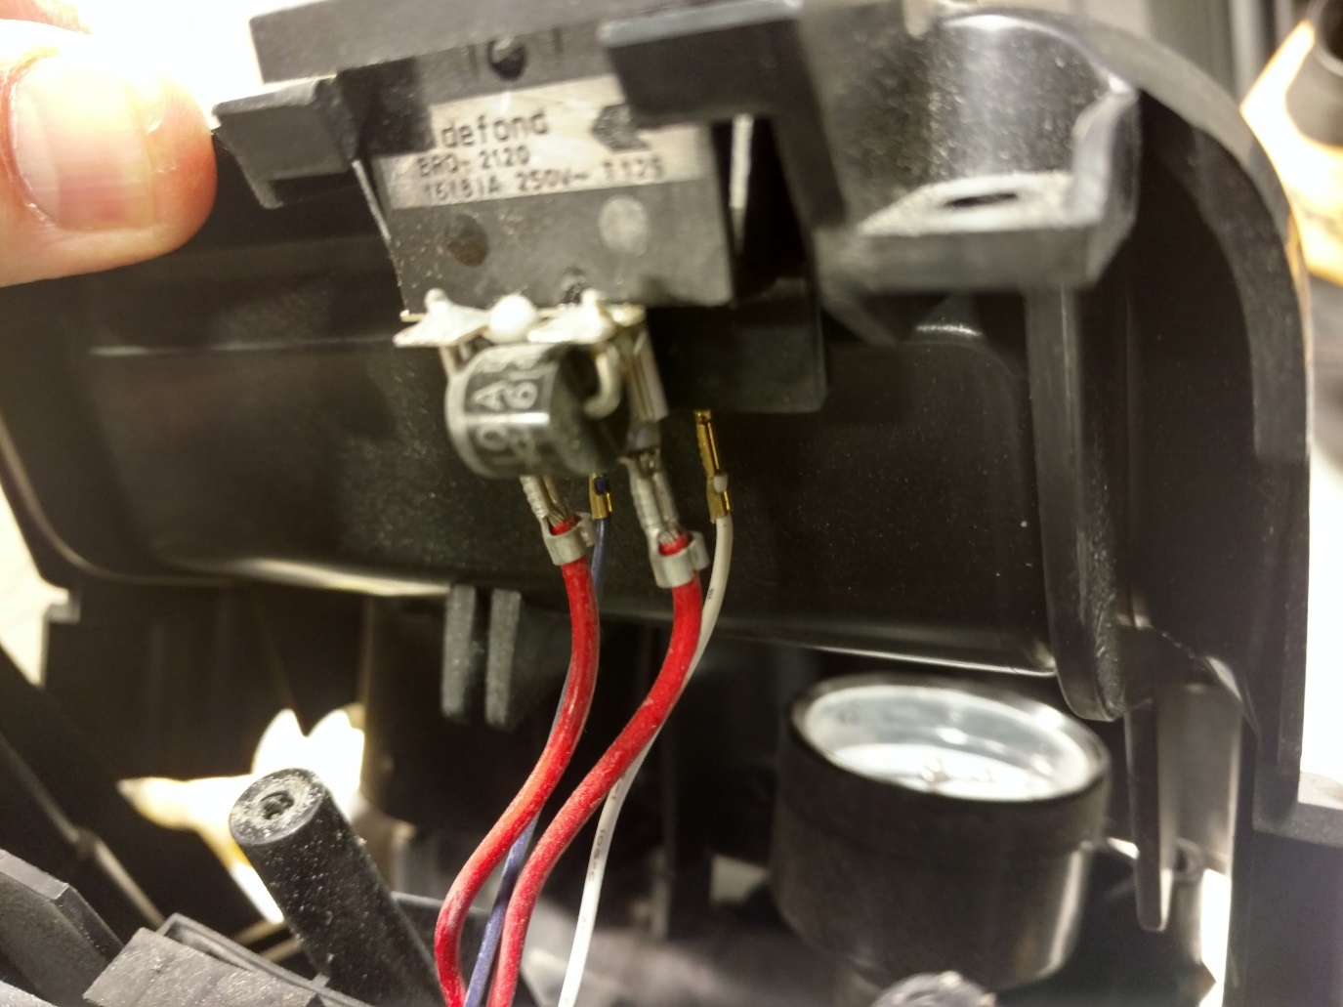

Insert switch into bezel.